API-Project

GET request to localhost

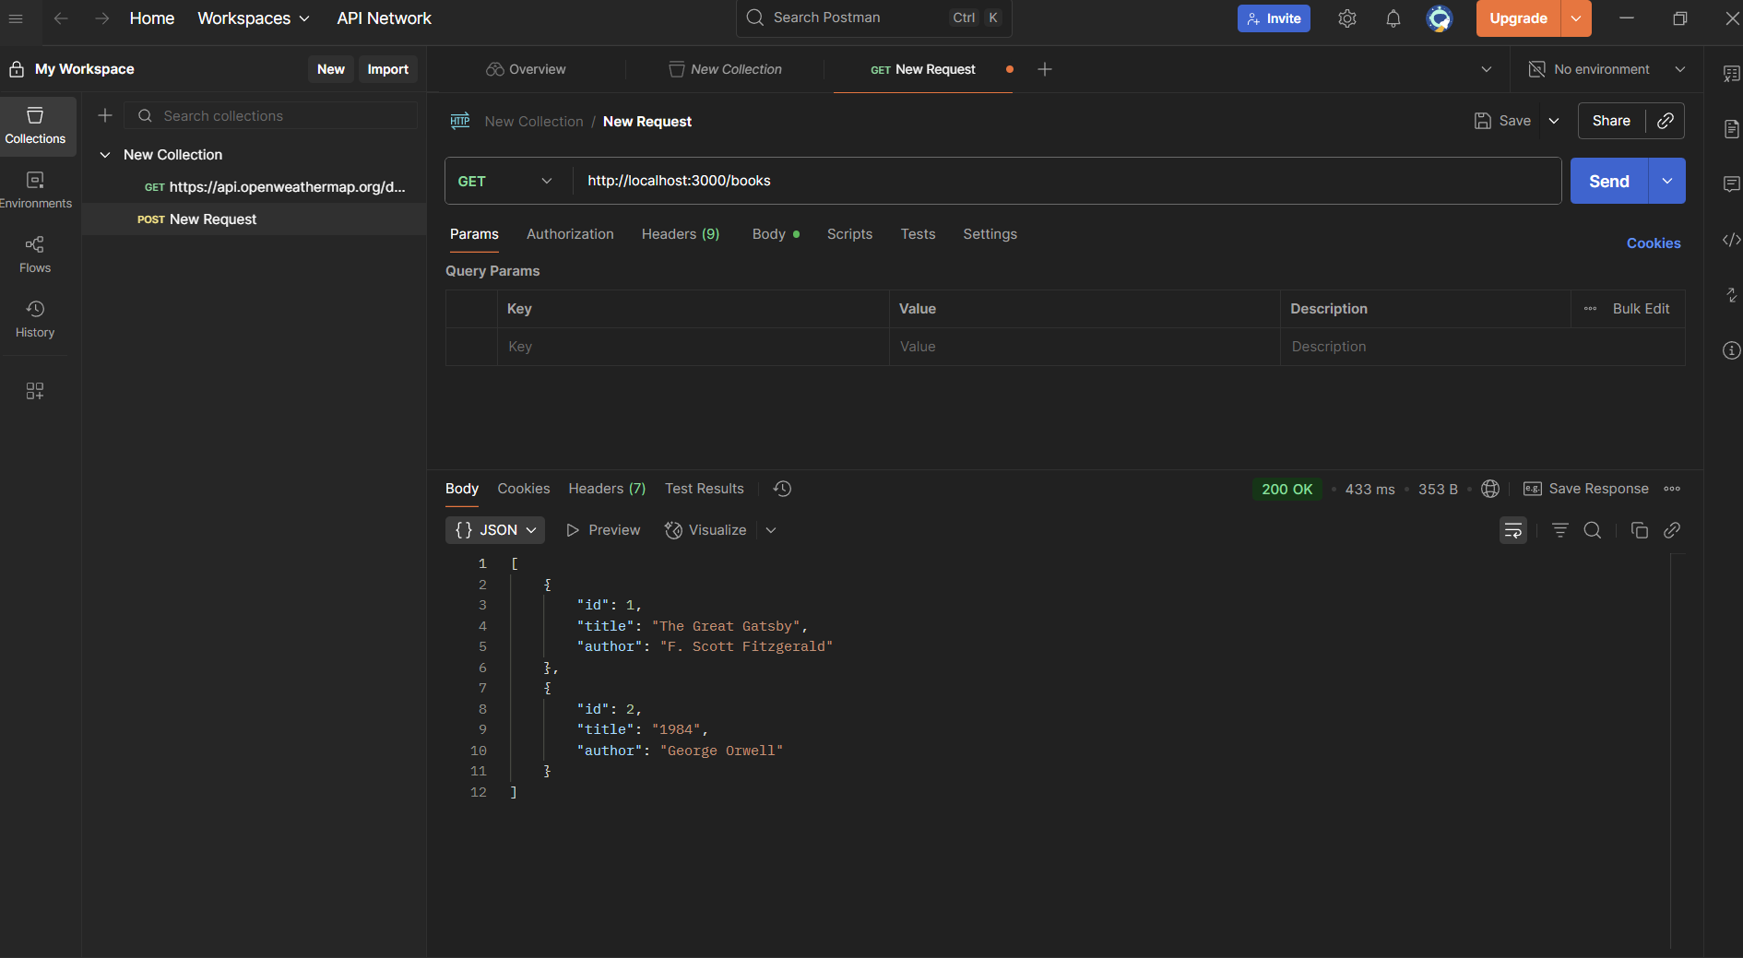

POST Request (Create a new book):

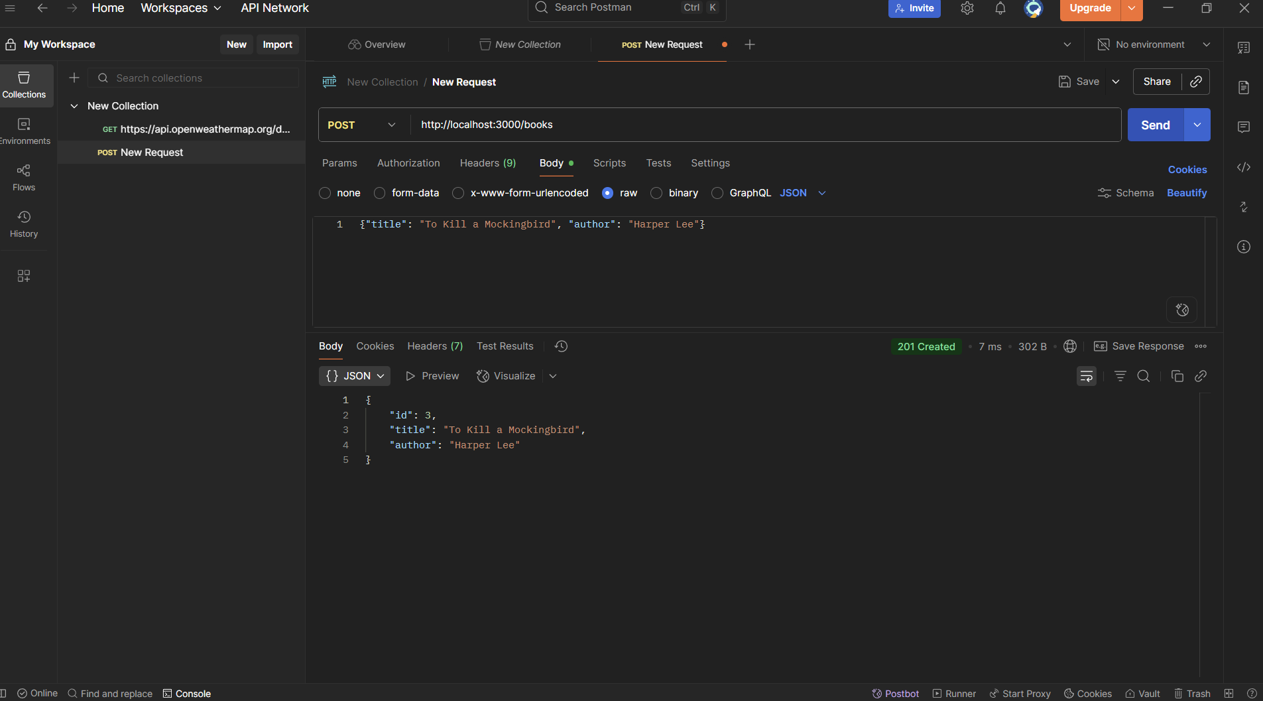

PATCH Request (Update a book):

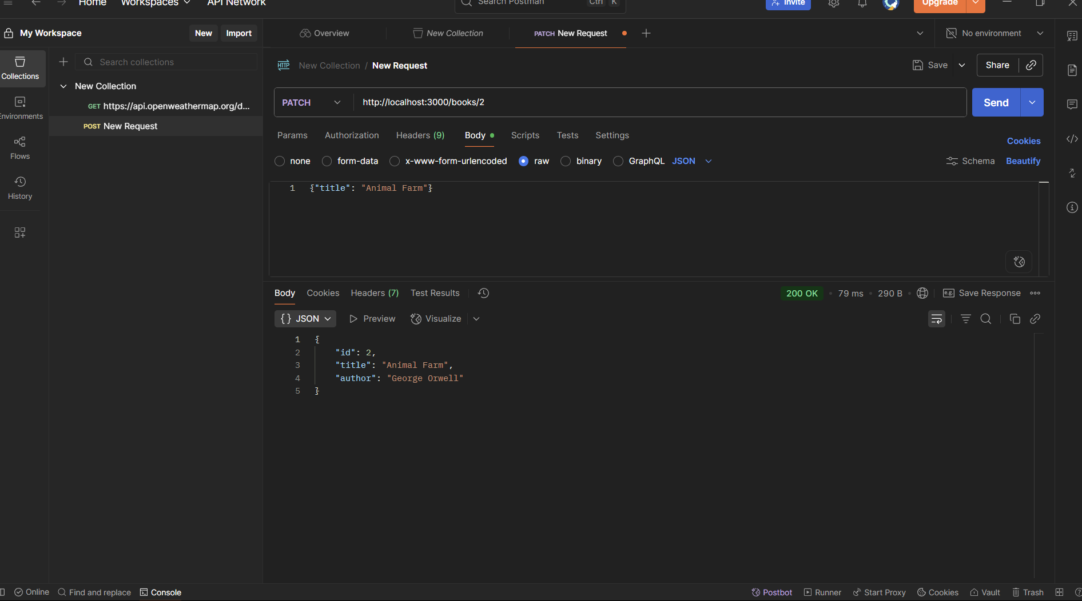

DELETE Request (Delete a book):

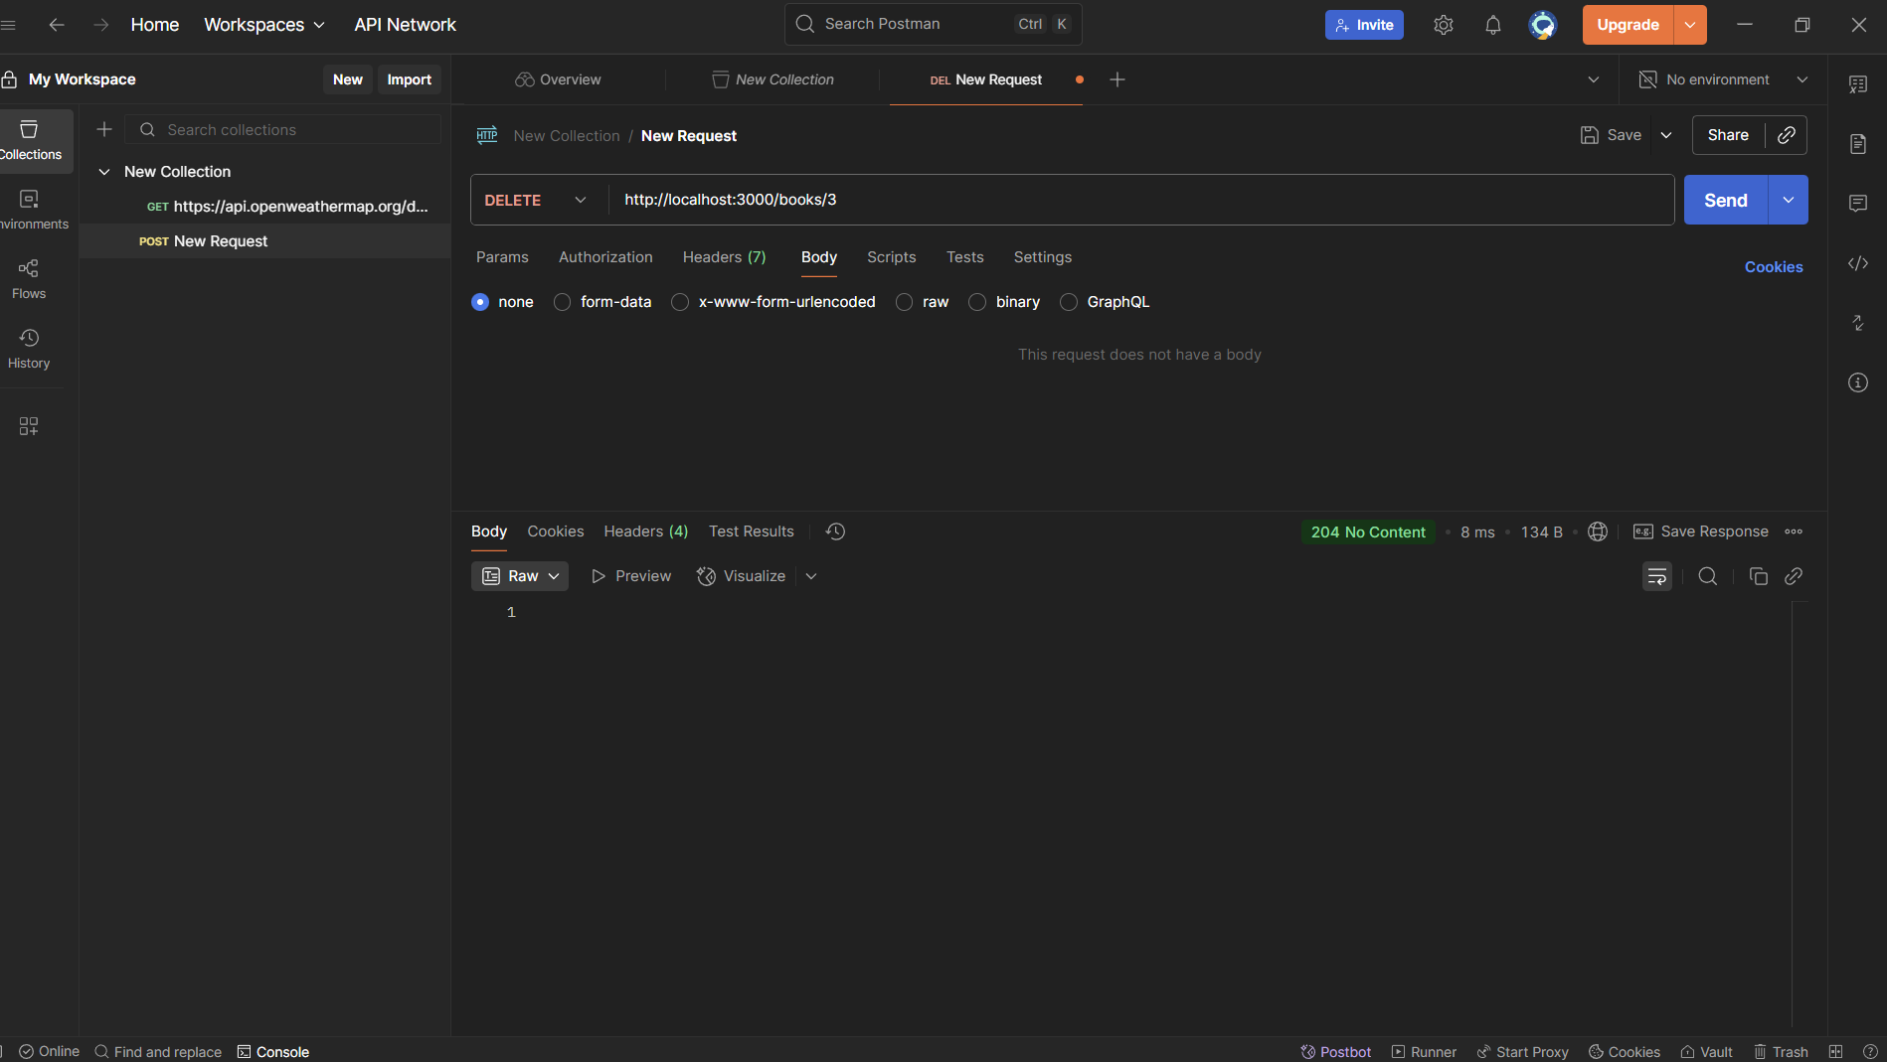

Postman DELETE request with no body, green 204 status, and empty response body indicating success.